Box plot for ssc_b and ssc_p

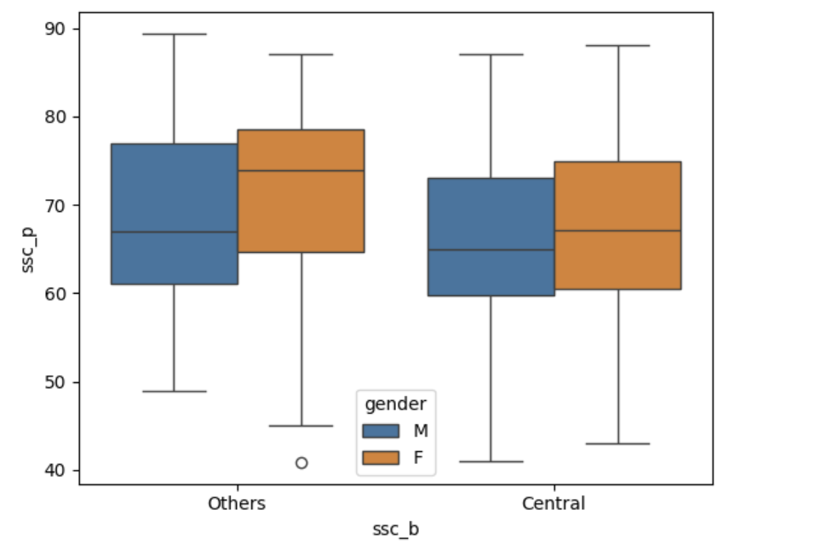

Quartile | Others Board |  | Central Board
Quartile | Male | Female | Male | Female
Initial(min) | ~ 49 | ~ 45 | ~ 41 | ~ 43
Q1 | ~ 61 | ~ 65 | ~ 60 | ~ 62
Q2(median) | ~ 66 | ~ 73 | ~ 65 | ~ 68
Q3 | ~ 76 | ~ 79 | ~ 72 | ~ 75
Q4(max) | ~ 89 | ~ 87 | ~ 87 | ~ 88

Summary:
Others(ssc_b):
- In the Others board, female students performed better on average than male students.
- Although female students had a higher average score, their minimum score was lower than that of male students.
- Although male students had a lower average score, they achieved a higher maximum score than female students.
Central(ssc_b):
- In the Central board, female students performed better on average than male students.
- However, the differences in the minimum, median, and maximum scores between male and female students are small.
Others(ssc_b) vs Central(ssc_b):
- Both male and female students from the Others board showed better average performance compared to Central board students.

